**DQL – JOINS, SUBQUERIES, GROUP BY**

1. What is the total revenues in 1997 ?

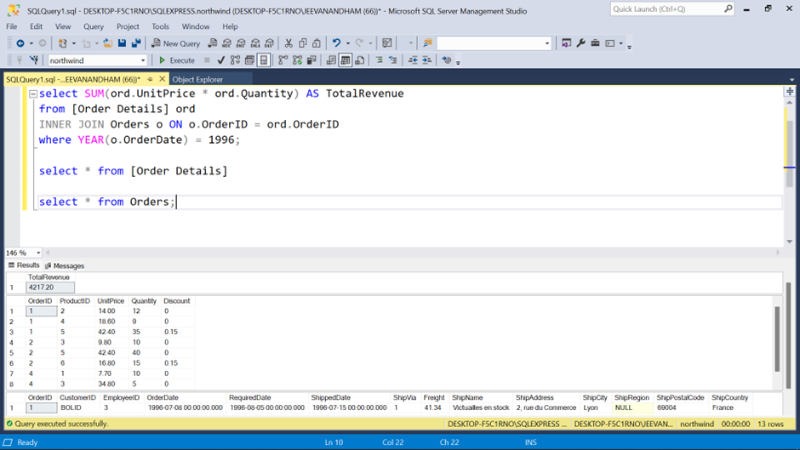

1. What is the total amount each customer has paid us so far?

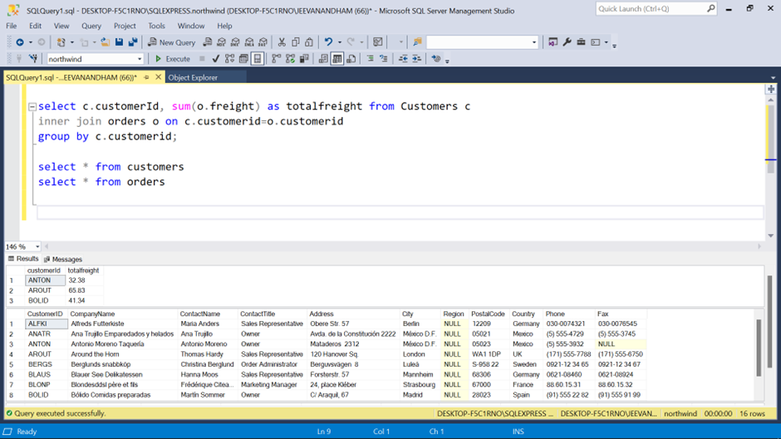

1. Find the 10 top selling products

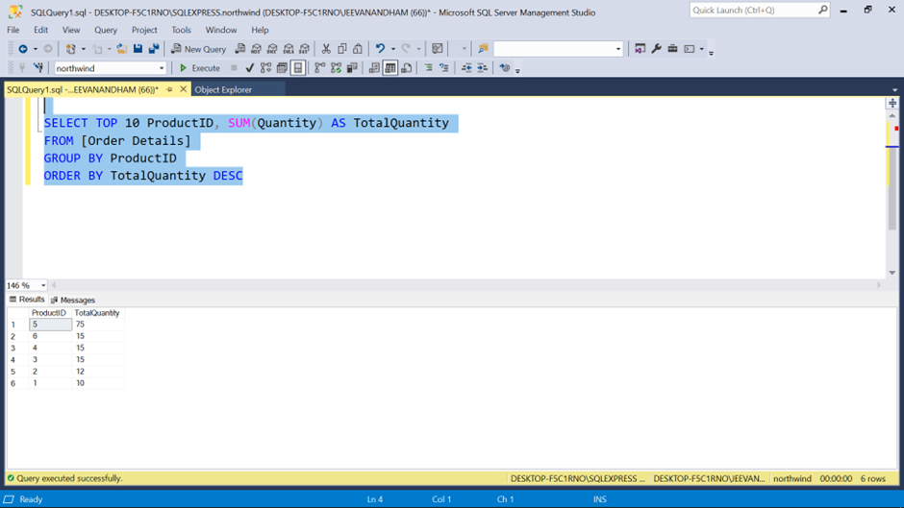

1. Display the total revenues per customer

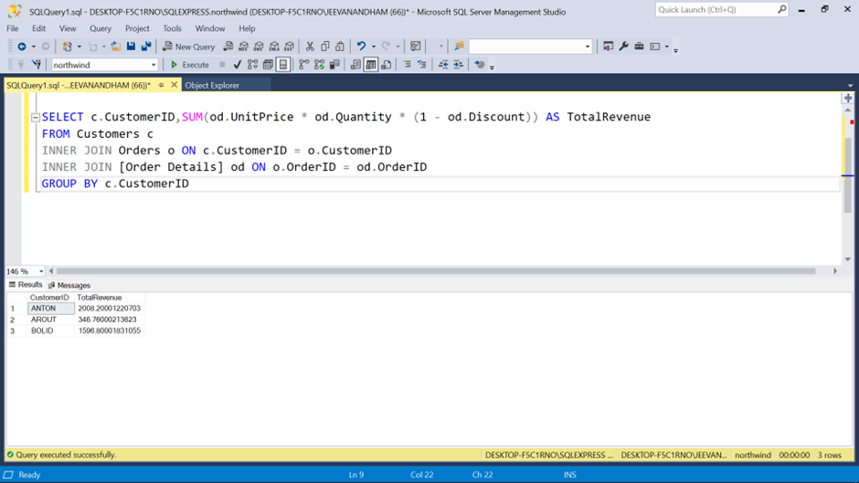

1. Which UK Customers have paid us more than 1000 dollars?
2. Display OrderID, total number of Order ID as NumberofOrders from the orderdetails table grouped by OrderID and sorted by NumberofOrders in descending order.

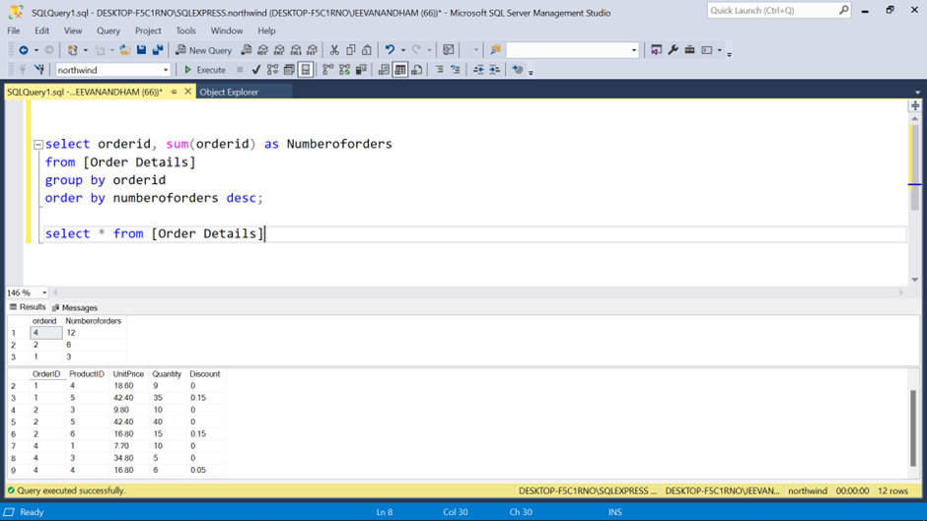

1. Display the SupplierID, ProductName, CompanyName from all product Supplied by Exotic Liquids, Specialty Biscuits, Ltd., Escargots Nouveaux sorted by the supplier ID

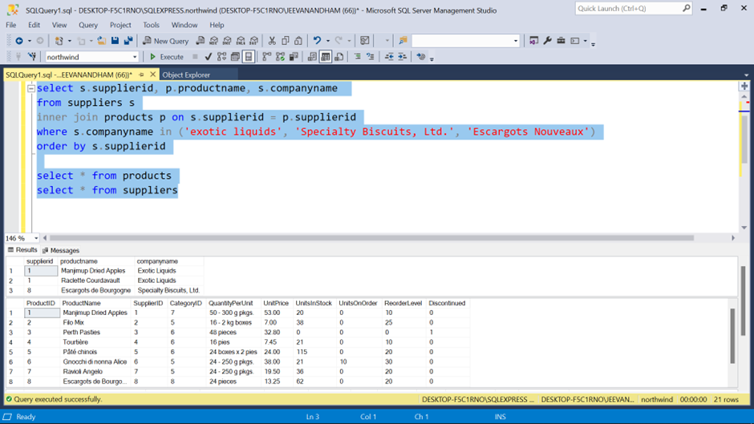

1. Display the ShipPostalCode, OrderID, OrderDate, RequiredDate, ShippedDate, ShipAddress of all orders with ShipPostalCode beginning with "98124".

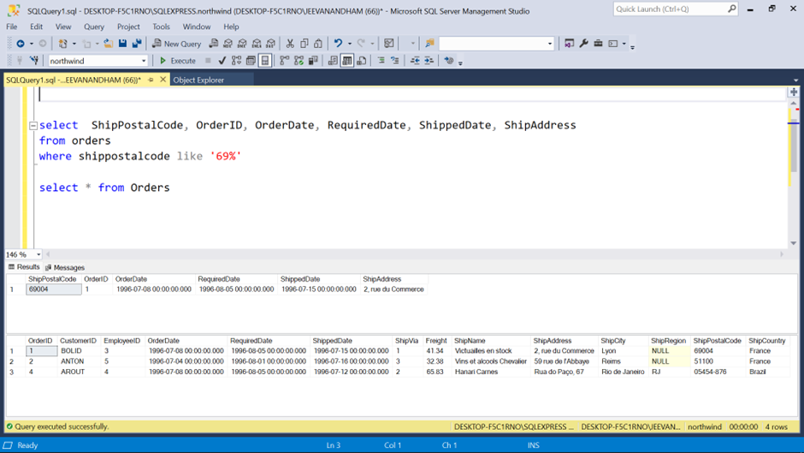

1. Display the ContactName, ContactTitle, CompanyName of customers that the has no "Sales" in their ContactTitle.

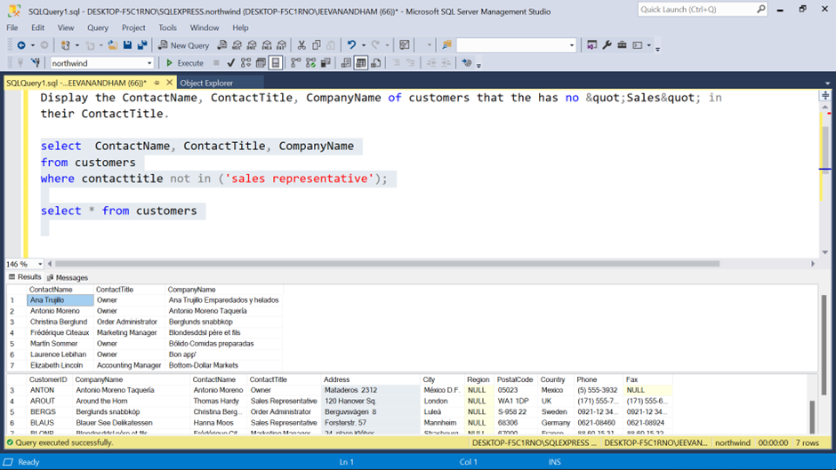

1. Display the LastName, FirstName, City of employees in cities other "Seattle";

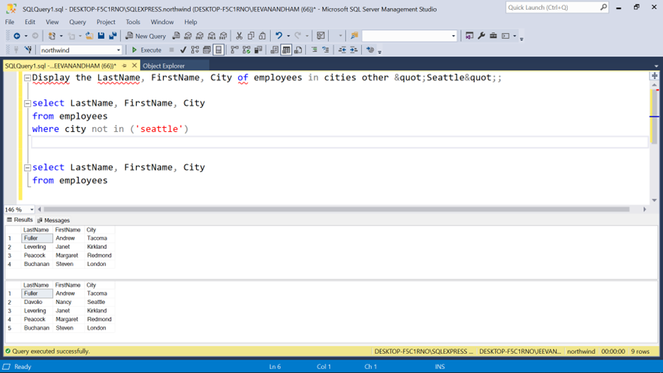

1. Display the CompanyName, ContactTitle, City, Country of all customers in any city in Mexico or other cities in Spain other than Madrid

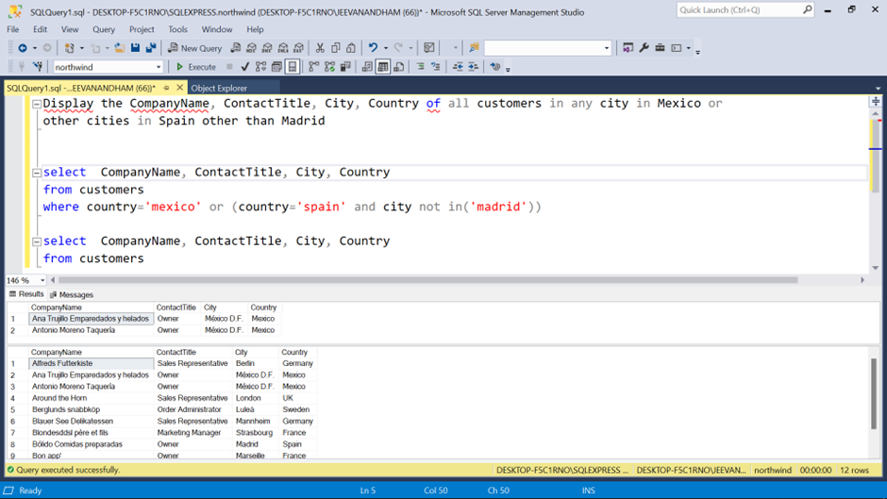

1. Display the ContactName of all customers that do not have letter A as the second alphabet in their Contactname.

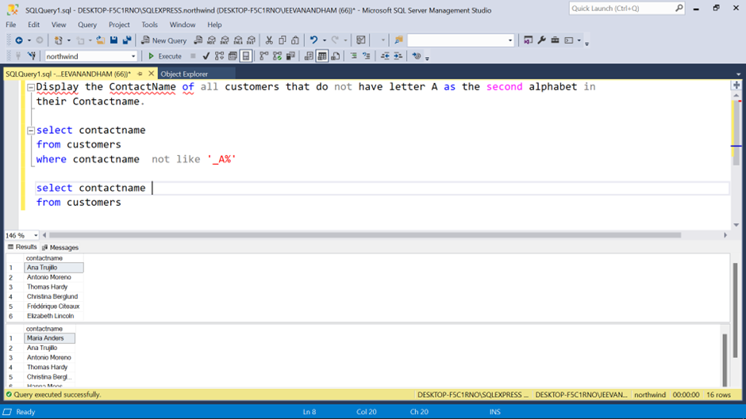

1. Display the average UnitPrice rounded to the next whole number, total price of UnitsInStock and maximum number of orders from the products table. All saved as AveragePrice, TotalStock and MaxOrder respectively.

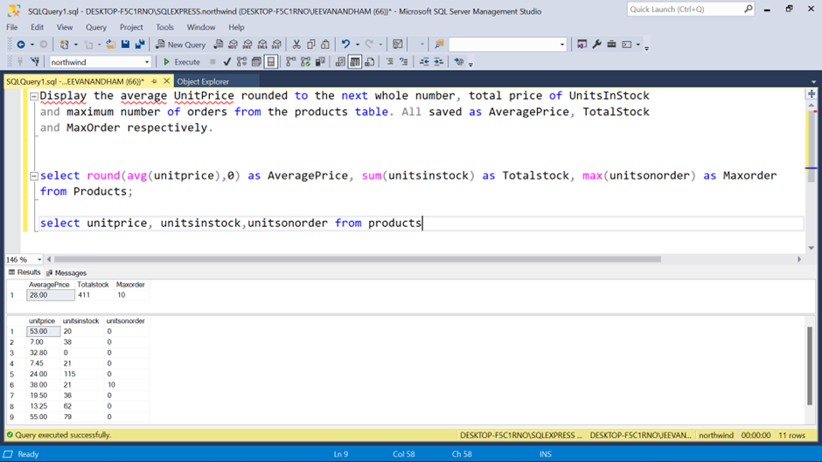

1. Display the SupplierID, CompanyName, CategoryName, ProductName and UnitPrice from the products, suppliers and categories table.

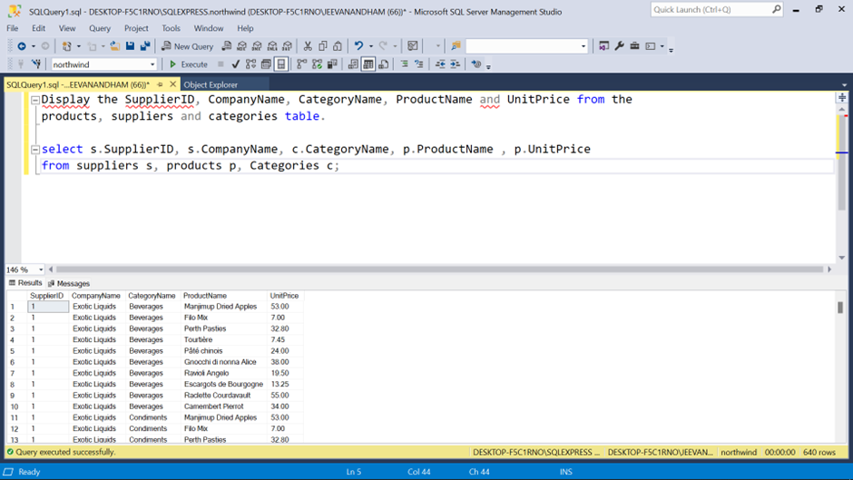

1. Display the CustomerID, sum of Freight, from the orders table with sum of freight greater $200, grouped by CustomerID. HINT: you will need to use a Groupby and a Having statement.

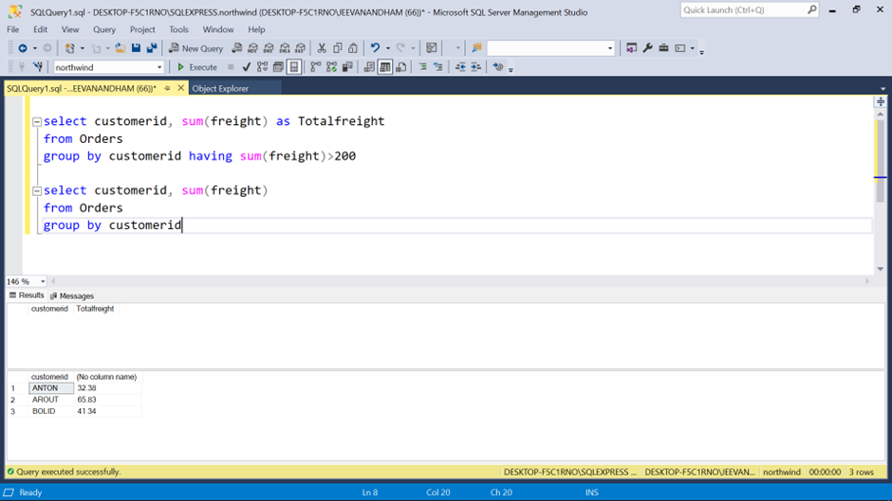

1. Display the OrderID ContactName, UnitPrice, Quantity, Discount from the order details, orders and customers table with discount given on every purchase.

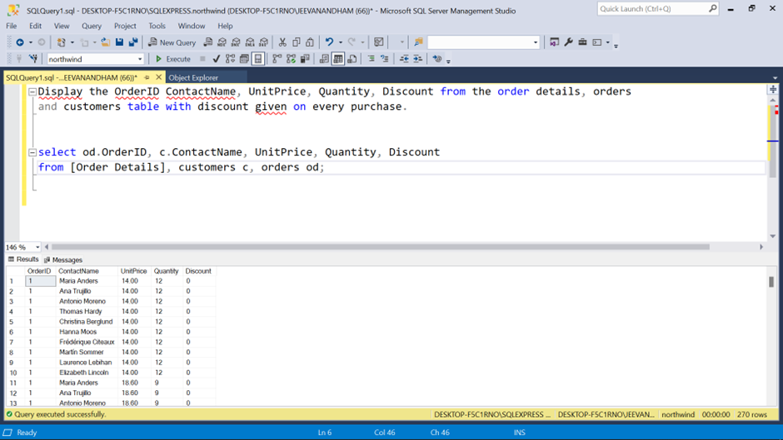

1. Display the EmployeeID, the LastName and FirstName as employee, and the LastName and FirstName of who they report to as manager from the employees table sorted by Employee ID.

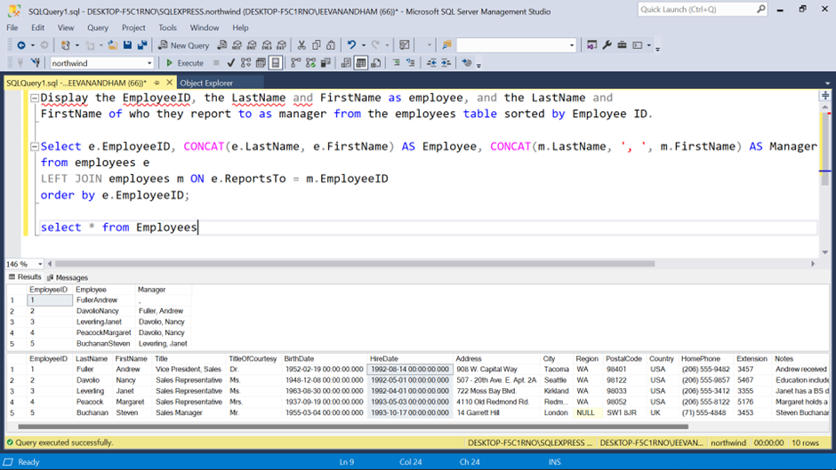

1. Display the average, minimum and maximum UnitPrice of all products as AveragePrice, MinimumPrice and MaximumPrice respectively.

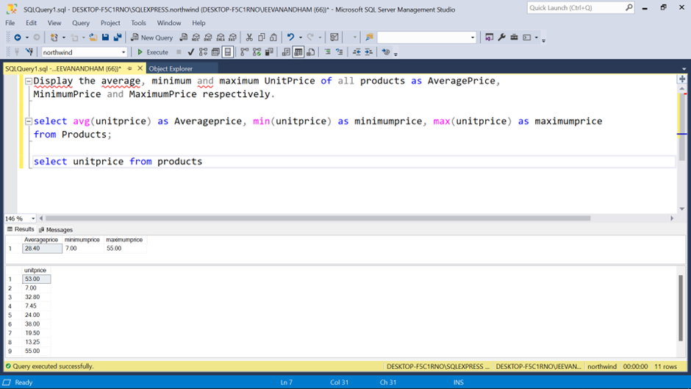

1. Display the first 5 character of categoryName from the category tables and renamed as ShortInfo

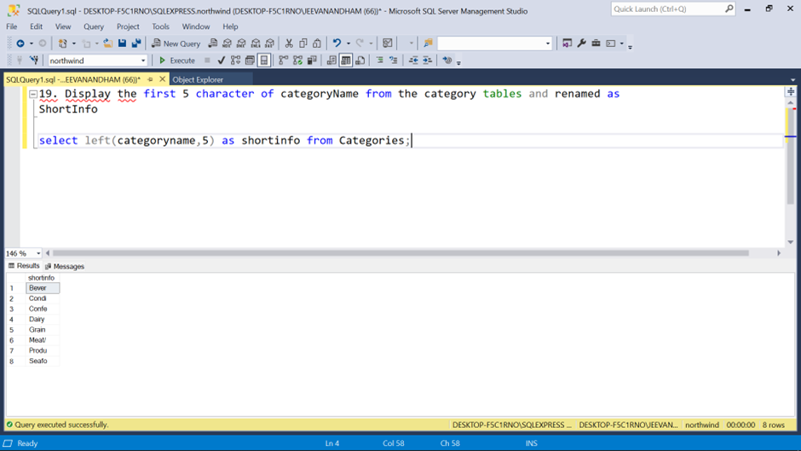

1. Display the CompanyName and total number of orders by customer renamed as number of orders since December 31, 1994. Show number of Orders greater than 10.

